SURREY LADIES LEAGUE CROSS COUNTRY MATCH 4

RICHMOND PARK, SATURDAY 10TH FEBRUARY

HOSTED BY RANELAGH HARRIERS

LOCATION

The race will be held in Richmond Park. The start/finish area will be near Sheen Cross roundabout, close to Sheen Gate and Roehampton Gate. This is a new location, at the request of the Royal Parks Agency.

The location of the start and finish, the course and car parks is shown below.

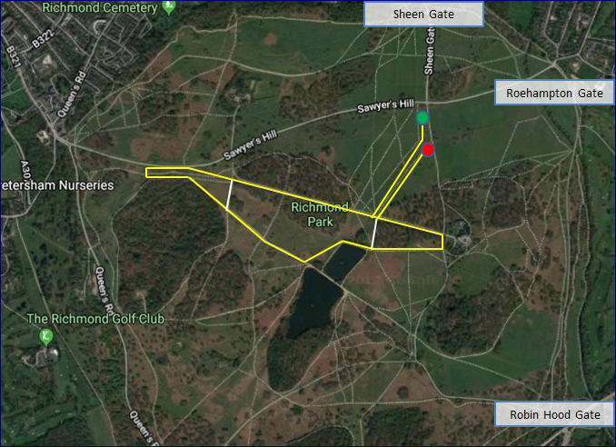

More information about the park, including a detailed map, can be found on the Richmond Park website.

TIMETABLE

There will be separate Senior Women’s races for Divisions 1 and 2. As agreed at the League AGM, the race order is reversed from the previous fixture.

11.00 am Senior Women Division 2 two long laps approx. 8.3 km

12.00 pm Under 15 Girls / Under 17 Women one long lap approx. 4.7 km

12.30 pm Under 13 Girls one short lap approx. 3.2 km

1.00 pm Senior Women Division 1 two long laps approx. 8.3 km

NB: Distances were measured on a GPS watch and should be taken as a guide.

COURSE

Course maps for each race are attached

Winter rain has made the ground soft and the surface slippy. Spikes are recommended, though trail shoes may be worn.

From a wide and bumpy start, the course makes its way to the Jubilee Pond before following a grass path beside a brook to the foot of Queen’s Ride and the start of the lap.

Turn right and ascend Queen’s Ride, all the way up until the road is reached. Follow the road to a dip, where there is a narrow path on the left. After a short while, cross the horse ride where there is a large clump of reeds and immediately bear left, to join the main path around Sidmouth Wood. Follow this path all the way down the hill to the Pen Ponds. Turn left before the ponds onto the grass then bear right to run beside the lower Pen Pond. Continue up towards the Ballet School before two left turns lead to a descent to the bottom of Queen’s Ride and the end of the lap. Senior Women will run two laps.

Turn right at the bottom of Queen’s Ride to follow another grass path beside the brook to the finish.

In the Under 13 race, the course turns around at the top of Queen’s Ride, missing the open section along the road and by Sidmouth Wood. Later, it misses out the section up to the Ballet School, cutting left towards the bottom of Queen’s Ride, immediately after passing the lower Pen Pond.

BANNERS, TENTS, BELLS AND HORNS

The Royal Parks Agency has agreed to the erection of banners and flags, in a marked area alongside the start. However, tents are not permitted. Neither is the use of cow bells, horns or similar instruments.

Please abide by these instructions and do not jeopardise the future use of the park for races.

TRANSPORT

Richmond Park covers a large area and is bounded to north by the A305 and A205 (South Circular Road) between Richmond and Barnes, to the west by the A307 between Richmond and Kingston, to the south by the A308 and A3 between Kingston and Roehampton and to the east by the A306 through Roehampton.

There are five vehicle entrances to Richmond Park: Roehampton Gate (north east), Sheen Gate (north), Richmond Gate (north west), Ham Gate (west) and Kingston Gate (south west).

For travel by public transport, please consult the National Rail and Transport for London websites.

The closest railway stations are at Richmond, Mortlake, Barnes and Kingston and are part of the South Western Railway network.

From Richmond or Kingston stations, take the 371 bus to the American University bus stop. Richmond Gate is around the corner and from there it is approximately 1¼ miles to Sheen Cross roundabout. From Mortlake Station, Sheen Cross roundabout is approximately 1¼ miles via Sheen Lane and from Barnes Station approximately 1¾ miles via Priory Lane.

PARKING

The nearest car parks are at Sheen Gate and Roehampton Gate. Both are within ½ mile of the start.

Those attending the Men’s Division 1 and Young Athletes’ races on Wimbledon Common may wish to park at Robin Hood Gate, about 1½ miles from the start. A pedestrian crossing immediately outside the gate allows safe crossing of the A3 and a path on the other side leads to the Richardson Evans Memorial Playing Fields and the Thames Hare & Hounds HQ.

Please be aware there is no vehicle access at Robin Hood Gate and that gates allowing vehicle access to Richmond Park will be closed at 5 pm.

FACILITIES

There are no changing facilities. Please come ready changed.

Toilets are available at Sheen Gate, Roehampton Gate and Robin Hood Gate car parks. Some of the toilets in the park may incur a 20p charge for use.

There is a café at Roehampton Gate car park

NUMBERS

All declarations are to be made online at https://surreyleague.org/. Numbers were issued at Match 1 and athletes are to wear the same number for each of the four Surrey league matches.

RESULTS

Provisional results will be compiled following the race and will be posted on the Surrey League website. These will be provisional and subject to change. Final results will be updated accordingly on the website. We plan to video the finish funnel to assist us with our results.

HOSPITAL

The nearest hospital is Kingston Hospital, Galsworthy Road, Kingston KT2 7QB. Tel: 020 8546 7711. (exit the park via Kingston Gate). A defibrillator is available in Pembroke Lodge

HELP

Any offers of assistance from friends, family or injured runners, out on the course or at the finish, will be greatly appreciated, even for only one race.

FUTURE RACES

Ranelagh Harriers will be staging two road races later this year, a half marathon and a 10k. Both are part of the Surrey Road League and incorporate the Surrey County Championship for the respective distances. Entries for both races are now open.

Ranelagh Harriers Richmond Half Marathon May 6th. Entries
Ranelagh Harriers Richmond 10k June 17th Entries

RICHMOND PARK

Richmond Park has protected status as an important habitat for wildlife and is a National Nature Reserve, London's largest Site of Special Scientific Interest and a European Special Area of Conservation. Please follow Sir David Attenborough’s request to Tread Lightly in Richmond Park.

Please be aware that the deer in Richmond Park are wild animals, roam freely and can be unpredictable. Also be aware of the presence of ticks and oak processionary moth.

Please also respect the other visitors to park, who have as much right to be there as we do.

QUERIES

Please email ranelagh.women@gmail.com with any questions.

