APRIL 2013 ISSUE 5

VIRGIN LONDON MARATHON
VOLUNTEERS MONTHLY

THANK YOU!
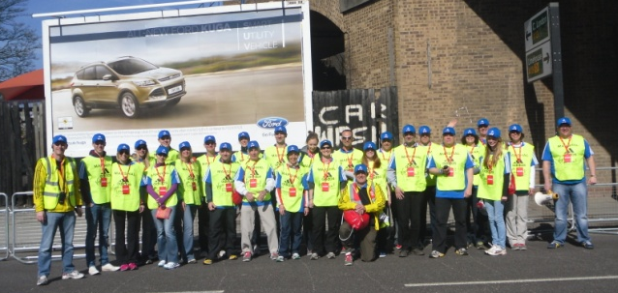

Thank You from all of the VLM team for all your hard work last Sunday. It goes without saying that we couldn’t have put on such a great event without the amazing volunteer workforce.

We really appreciate all the hard work put in by team leaders to organise teams in the lead up to the day and also all the volunteers out on the course ensuring the runners and spectators have a great time!

Claire

2013 Virgin London Marathon.

More than 700,000 people witnessed some spectacular achievements by the event’s elite athletes and watched more than 34,000 people make the 26.2 mile journey from Blackheath to The Mall.

The London Marathon pledged to donate £2 for every finisher to The One Fund Boston set up to help those affected by the incidents, so with 34,278 crossing the line yesterday the London Marathon’s 2013 runners have raised £68,556 for the fund.

There were some incredible performances from the elite fields including a world record for El Amin Chentouf in the IPC World Cup and a course record by Tatyana McFadden in the women’s wheelchair race.
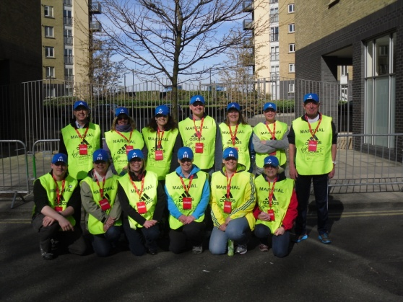
The 2010 champion Tsegaye Kebede came back to win again in the men’s race and the women’s race saw Priscah Jeptoo move from her 3rd position last year to triumph this time.

Other Info:

If you have photos of you and your team in action please send them through to clairel@london-marathon.co.uk. You may make it into next year’s marshals handbook!

Please send any volunteer sign in lists and any debrief points from the day to the above email address. It is important that we have a record of everyone who volunteered on the day.

Not that we are wishing the year away but here is a date for your diary. Next year’s event will take place on April 13th 2014. The ballot has already closed in record time so it is looking like another exciting marathon!

