**MAY 2013 ISSUE 6**

**VIRGIN LONDON MARATHON**

VOLUNTEERS MONTHLY

**Bupa Westminster Mile & Bupa London 10,000**



This weekend we had a new event – The Westminster Mile - which we delivered in partnership with Westminster City Council. This took place the day before the Bupa London 10,000. With over 25 one mile races we were all kept busy!

Mo Farah secured his fifth consecutive Bupa London 10,000 title with a effortless victory after helping to inspire a new generation of runners starting the youth races at the Bupa Westminster Mile.

Thank you to all the groups who took part in these events. We couldn’t have done better with the weather and both events were a great success.

**Claire**

**London Marathon and Virgin Money announce a new sponsorship deal!**

The London Marathon announced a five-year extension to its sponsorship deal with Virgin Money today, and revealed a new race logo and title for 2014.



Virgin Money, the banking division of the Virgin Group of the companies, will continue as London Marathon sponsor until at least 2017, while the race will change its name from the Virgin London Marathon to the Virgin Money London Marathon from next year.

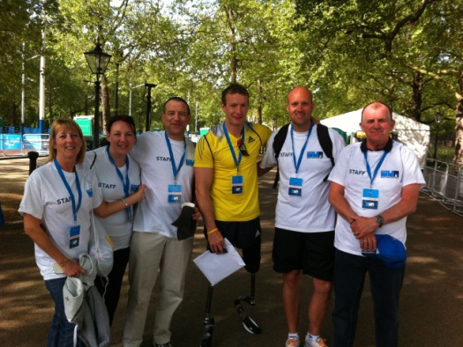Virgin Money first became the title sponsor of the event in 2010 with the aim of helping runners raise £250 million for charity over five years. In the first three years of Virgin Money sponsorship, runners raised more than £150m. In 2012 a record-breaking £52.8m was raised, of which more than £17.8m was raised through the Virgin Money Giving not-for-profit online fundraising service.

**Other Info:**

Attached along with this newsletter an article that was in the New York Times about the Boston bombing and the solidarity felt with the runners at London Marathon.

Next big event – Prudential RideLondon! More information can be found at [www.prudentialridelondon.co.uk](http://www.prudentialridelondon.co.uk). If your team are interested in volunteering get in touch. This event will be running over 2 days in London and Surrey. The FreeCycle & Grand Prix events will take in Central London. Then 20,000 riders will then depart the Olympic Park between 6-8am taking part in the London-Surrey 100 followed by over 150 pro-cyclists in the afternoon.

* We have our multi agency debrief on the 20th June, if you haven’t sent your feedback in please do so asap.