JANUARY 2013 ISSUE 2

VIRGIN LONDON MARATHON
VOLUNTEERS MONTHLY

HAPPY NEW YEAR!

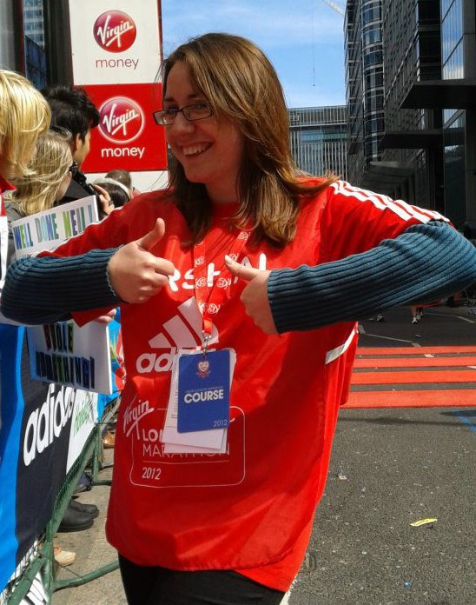

I hope you all had a lovely Christmas and New Year. The events season is just around the corner with The Silverstone Half Marathon on 3rd March and from then they keep on rolling until August!

I am currently getting up to speed on the ins and outs of volunteering at LM and how it has evolved over the many years. Lisa of course knows who you all are but it would really help me if group leaders could send me the name of your team/club/group so that I can create a credit list for the Final Instructions Magazine sent to all runners in March and the donation cheque post Marathon.

Claire

New Team Member!

It’s all change in the Operations Department. Following the departure of Martin Mashford for sunnier climes in Aus (with this snow who can blame him) Ben Craddock has been recruited for the role of Operations Coordinator. Previously on the Help Desk, Ben’s main responsibilities will be Mini Marathon but also working on volunteer equipment so you may meet him soon.

IPC Athletics Marathon World Cup.

New for 2013! This year will see the IPC Athletics Marathon World Cup Event taking place within the Virgin London Marathon on 21st April. This event will be for visually impaired and ambulant athletes. There will be a maximum of 50 participants this year with the hope it becomes a legacy event in the future.

The start will be at 09.22am with the elite women at 09.00am and elite wheelchair at 09.20am as usual. This means the elite men’s and mass race will start at 10.00am to allow appropriate gaps between the finishes of all racers for the BBC to include them in their live coverage.

Other Info:

Later this month we will start the sector walk rounds for the Marathon. We believe we have captured all the debrief points from 2012, but if there is anything pressing you have thought of please let us know and we will try and incorporate into this year’s planning.

Do remember that the guaranteed entry deadline is the 8th February and the entry department will not be accepting late entries.

Queen Mary’s University have already sent in some cracking photos for the marshals handbook. If you think you can do better and have a front cover worthy photo please send it through to me clairel@london-mara thon.co.uk. I hear that Queen Mary’s have made it onto the front cover for the past few years – can they be outdone??!!

